Objective :Credit card transaction and Weekly Customer report
To develop a comprehensive credit card weekly dashboard that provides real-time insights into key performance metrics and trends, enabling stakeholders to monitor and analyze credit card operations effectively

- Project Overview : This project analyzes customer credit card usage behavior using transactional data from 10108 purchases across various services and purchases. The goal cover insights into Week on Week generation of revenues through Interest earned on credit card, the Activation rate of cards ,spending patterns, usage pattern, the revenue classification in terms of age groups of customers,by job category, by marital status and gender and various other factors.

- The analysis also includes the total transaction numbers on weekly and Quarterly basis affecting the revenue. The Customer acquisition cost of various types of credit cards also to be analysed.
and to guide strategic business decisions.

- Dataset Summary - Rows: 10108, Columns: 18 in Table CREDIT_CARD
Key features:-Credit card type(Blue,Silver,Platinum,Gold), Number of transactions done,Interest earned,Credit limit,Annual fees,Week number start date,quarter ,customer acquisition cost,revolving balance,average utilization ration,whether delinquent account or not, the type of expenses,total transaction amount,total transaction volume and client ID.
Table : CUSTOMER ,Rows-10108,columns-15
- Key Features: - Customer demographics (Age, Gender, Location, marital status,number of dependents) – Personal loan details,car ownership ,house ownership,Education details,Profession,income,contact number mode,Customer satisfaction score and client ID
Common column between the two tables-CLIENT ID

- Steps Followed in the Data ETL process:

1. Prepare csv file
2. Import data to SQL Database: Create tables in SQL
3. import csv file into SQL
4. Connect SQL Database to Power BI through “GET DATA” and load the data tables in Power BI.
5. Data processing & DAX queries to Create various measures meant for KPIs and for Data Analysis.
6 Create two Dashboard- One for “Credit card transactions” and another for “credit card Customer “.
7. Draw insights through Analysis and KPIs.
8.Prepare Weekly report for submission to Client with insights

IMPORTANT STEPS :
Step I : Database CCDB with two tables CC_DETAIL & CREDIT_DETAIL created in PostgresSQL .
This database is connected to Power BI. In power BI, to connect data tables,”GET DATA” is selected and POSTGRESQL user id/ password is entered. Upon which the data table are imported in Power BI.
Step II: Data processing &DAX query in POWER BI
- Added one column named age_group to segregate the age of customer data in age groups such as <30,”20-30”, “30-40”,”40-50”,50-60”,”60+”
- Another column named income group added to segregate income group as “ Low” ,”Medium” and “High” .
- Added another column “revenue” to calculate total revenue by adding annual fees+interest earned+total transaction amount.
Step III: Dashboard Creation-Two Dashboard-One for Credit Card Transaction and another for Customer related.
- Various measures created to find KPIs for Dashboard such as CURRENT_WEEK_REVENUE,PREVIOUS_WEEK_REVENUE,WOW INCREASE,SUM_REVENUE,DELINQUENT_RATE,ACTIVATION_RATE etc
- Data Visualization on Weekly Basis with drop down menu to select any week from 1st Week to 52 nd week.
- Various charts created for analysis such as REVENUE by GENDER,CUSTOMER JOBS,EXPENDITURE,EDUCATION LEVEL.
- Line & Bar chart for Quarterly Revenue and Total Transaction numbers
- Slicers for Quarterly display of Dashbord Data.
- Slicers for data visualization by MALE and FEMALE, by Card Category (BLUE,PLATINUM,GOLD,SILVER) ,by Card usage (SWIPE,CHIP,ONLINE)
- Credit Card Category wise tabular data of Revenue,Interest earned and total Transaction amount of all customers.
- In order to create dashboard on Weekly basis, the column “Week_num “ cannot be arranged in ascending or descending order and as such, separate column is created with WEEK_NUM_2 measure.
- To create a table for Week on Week visualization of Revenue data,DAX query required.The strategy involves making measures in BI for current week revenue, previous week revenue and the calculating the WEEK on WEEK changes in Revenue.

Step IV: WOW data feeding
- Two tables- Weekly data in the form of Table CUST_ADD having 185 rows of Data and same format with columns as Table CUSTOMER .
Similarly table CC_ADD table having 185 rows of data with same format and columns as Table CREDIT_CARD.
- The Weekly data for 53rd Week dated 31st December 2025 is updated in the SQL data base.
- The Data gets automatically updated in real time in the Dashboard with all KPIs and Charts reflecting the updated change in Data at 53rd Week.

Dashboard in POWER BI:
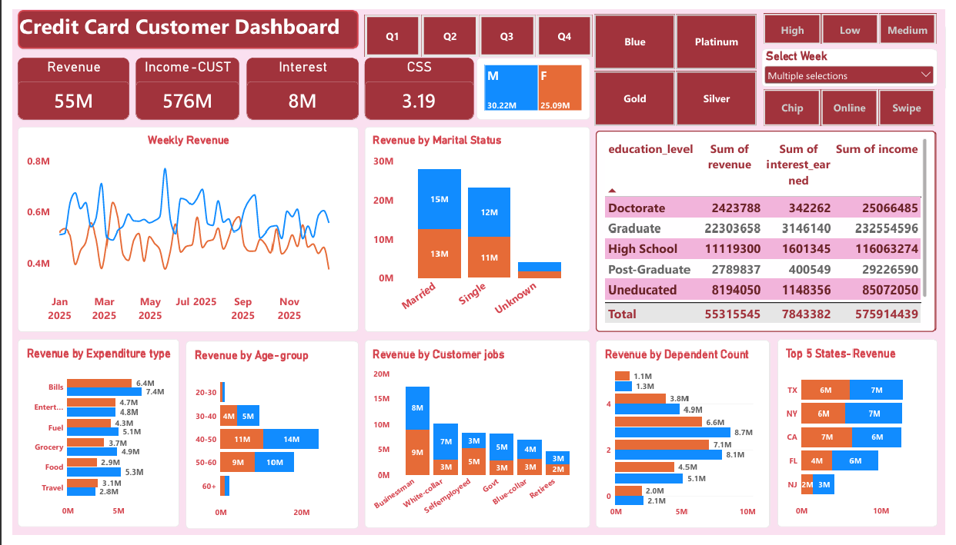

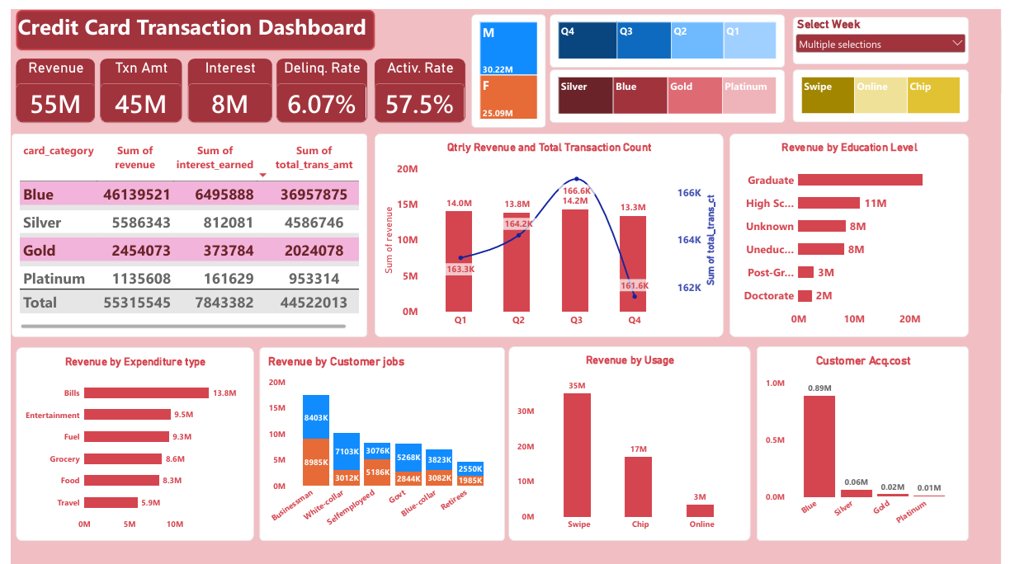

Insight for Week 52 ( 24 December 2025):
• Overall revenue is 55M • Total interest is 8M
• Total transaction amount is 45M
• Male customers are contributing more in revenue 30M, female 25M
• Blue credit card are contributing to 83% of overall transactions while Silver Credit card at distant second at 10% of total transactions
• TX, NY & CA is contributing to 77% with CA the highest grosser.
• Overall Activation rate is 57.5%
• Overall Delinquent rate is 6.06 %

WOW Status Report:
Weekly data for 31st December 2025 (Wek 53) containing 185 rows added in the CCDB database in postgress. This data got automatically updated in the existing 10108 rows of data. Which subsequently changes the KPIs in the two dashboard viz: Credit card transaction Dashboard and Credit card Customer dashboard, automatically in real time.
Separate dashboard for Week on Week to show revenue KPIs in “Thousands(K) instead of “Millions(M) created for understanding purpose.
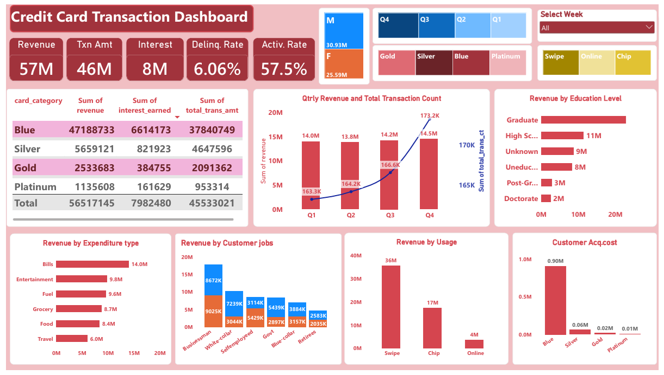
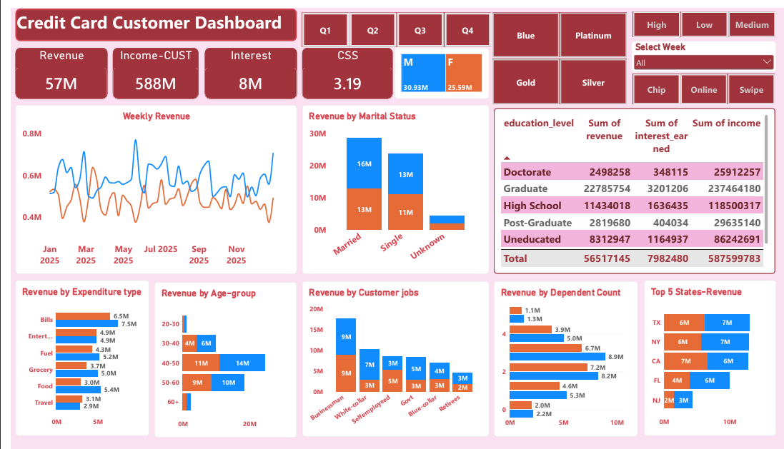

Dashboard for Week 53 (Reflecting WOW revenue):
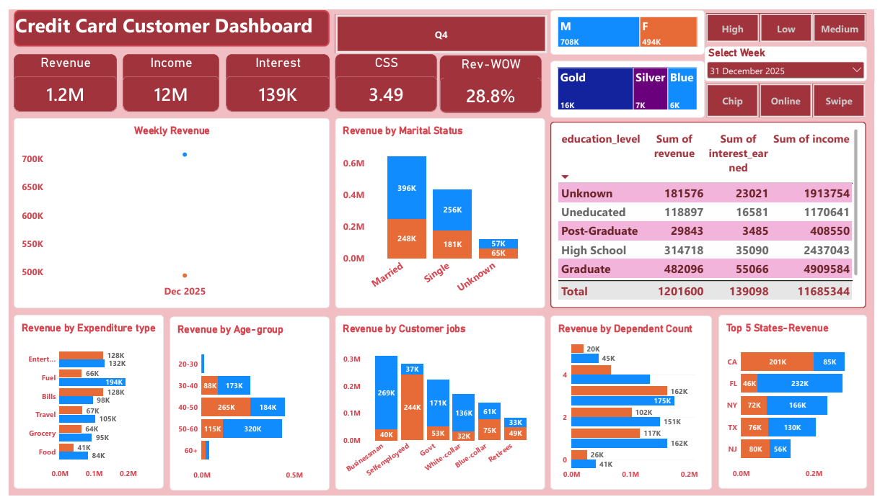

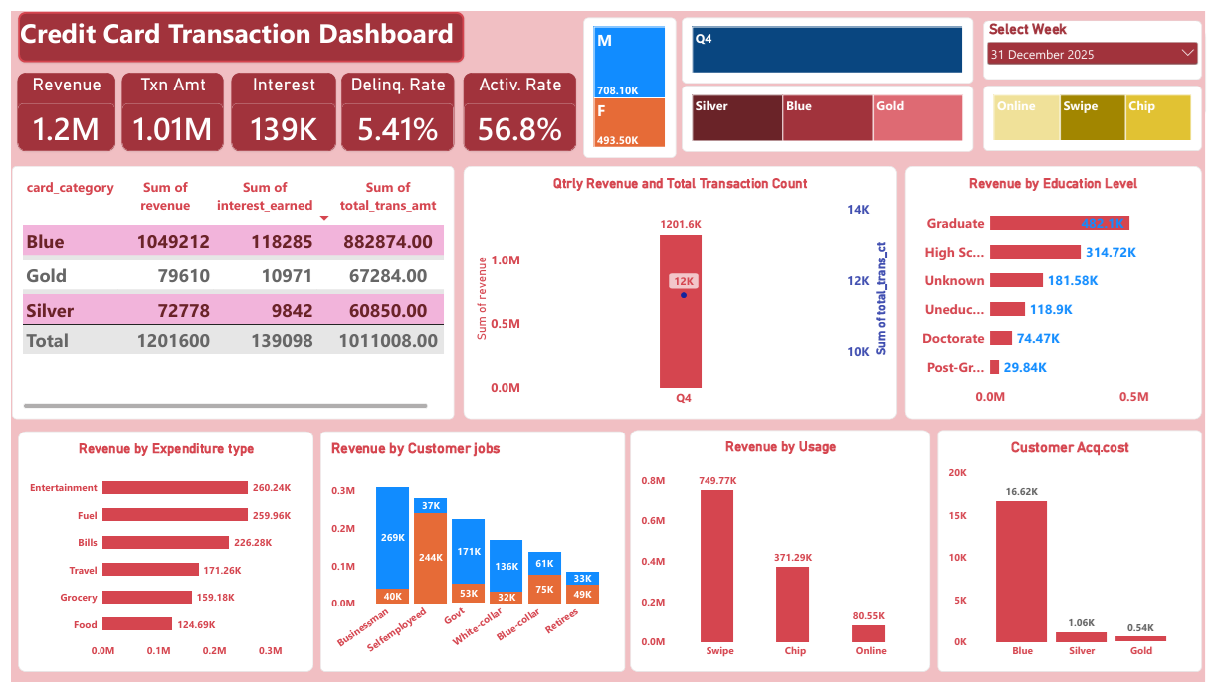
Insights Week 53 (31st Dec) WoW change:
- Revenue increased by-1M ( UP 28% )
- Income generated-12M
- Transaction amount -1M ( UP 33.5%)
- Interest earned for Credit card usage-139K
- Delinquent rate & Activation rate –5.41 % and 56.8%
- Customer count increased by 12.8%.
- Male gender contributed to 708 K in Revenue while female gender contributed 493K in revenue generation. Thus Male continues to be the dominant category.
- Customers used credit card for Entertainment and Fuel expenses ,the most at 260K each, out of 1M revenue.
- During the week,businessmen and self employed were highest revenue generators.
- Most of the Customers preferred to use the card by SWIPE which caused revenue generation of 749 K.
- The BLUE category Credit card generated highest revenue of 1.04 M and is most popular among Gold,Silver and Platinum Cards.
- Married men/women continued to contribute higher revenue 643K followed by Singles( Boys/Girls).
- CSS for the week was 3.49 which was higher than the yearly average 3.19 .

YTD:
• Overall revenue is 57M • Total interest is 8M
• Total transaction amount is 46M
• Male customers are contributing more in revenue 31M, female 26M
• Blue & Silver credit card are contributing to 93% of overall transactions
• TX, NY & CA is contributing to 68%
• Overall Activation rate is 57.5%
• Overall Delinquent rate is 6.06

Recommendations for Business actions:
- Only three states are contributing to 68%. There is a scope of widening the customer base in other 40+ states by targeting high income group individuals and businesses, thereby increasing revenue. Special incentives for Corporate clients may be introduced.
- The credit cards are mostly used for Entertainment and Fuel purchase. Suitable new and targeted marketing incentives may be given to new customers to entice and enrol them.
- Delinquent rate is 6.07% and the highest contributor is Self Employed Job Category at 1.65%. Hence it is recommended for cautious approach towards Self Employed category while issuing Credit cards.
- The activation rate is 57.47% with highest contributor by Self employed at 14% in this overall percentage. Remaining 42.53% have not activated their cards within 30 days. There is a scope for increasing the Activation rate by follow up and suitable incentives to Job categories – of Business man and White collar jobs so that Card Acquisition cost is not wasted and to widen subscriber base.
- CSS needs to be increased by proper follow up and resolving the grievances of customers timely.

https://agent.aippt.com/?share=b-nDneClytqnBSMyW1oTYQ#👆Check out my presentation on AiPPT.com: “Credit Card Weekly Dashboard”

